Past Performance: Middleware Modernization for Top 3 US Regulated Electric Utility

Client Context & Integration Landscape
A large east coast power company operating in a highly regulated environment relied on a legacy middleware platform (SAP Process Orchestrator, SAP PO) to provide connectivity, authentication, and protocol mediation between core assess management systems SAP and IBM Maximo.

SAP PO was approaching end-of-life and becoming an operational risk. The platform had escalating support costs, delayed modernization initiatives, and was limited in features to support modern architectures. It needed to be retired within a strict timeframe to meet compliance requirements..

This engagement represented the first proof of value (POV) for modernizing enterprise integrations within the organization. As the first workload to move through security, governance, and architectural review, the solution needed to demonstrate not only technical viability but also operational readiness within a regulated utility environment.

Legacy Integration Characteristics & Constraints
The legacy integration model centered on SAP PO acting as a centralized broker responsible for:
- Connectivity between SAP and IBM Maximo
- Authentication and header enrichment
- Protocol mediation across SOAP, RFC, and IDoc-based interfaces
- Timestamping and message transformation logic

Target Integration Architecture & Design Approach
AIS designed a cloud-native integration approach that replaced SAP PO’s responsibilities with Azure Integration Services, while preserving existing business workflows and technical contracts.
The target architecture introduced:
- Azure API Management (APIM) as the secure ingress point for enterprise integrations, responsible for authentication, policy enforcement, logging, and traffic management
- Logic Apps with SAP Connector to bridge protocol differences and communicate directly with SAP using RFC
- Secure secret management using Azure Key Vault
- Centralized monitoring and diagnostics aligned with enterprise operational standards

This design allowed SAP PO Middleware to be fully removed from the integration path, while increasing visibility, cloud native qualities, and improved operations excellence.

As-Is State – Azure Integration Service are not present
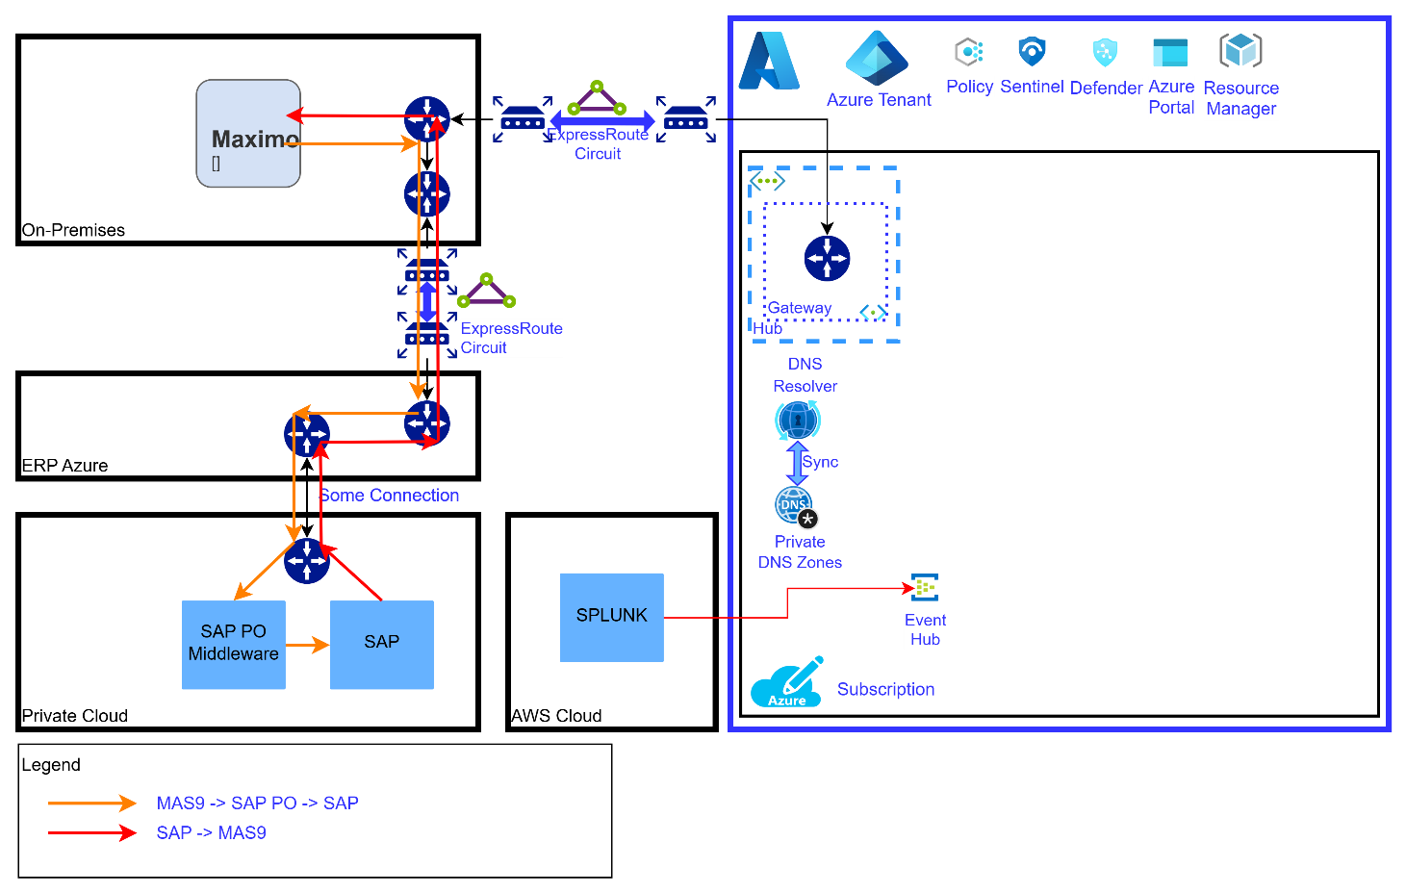

As-Built State – AIS Provisioned Azure Integration Service
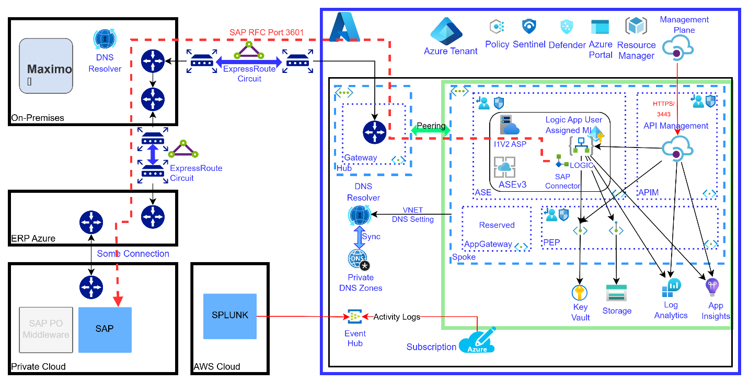

As-Built State – Use of Logic apps to communication to SAP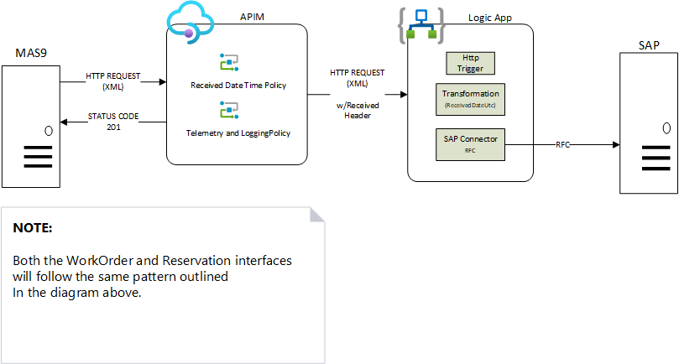

Integration Patterns Implemented
The solution focused on point-to-point enterprise integrations, similar in complexity and scope to many BizTalk-style workloads:
- SAP → IBM Maximo
  - SAP sent SOAP/XML payloads to Azure API Management
  - APIM enforced authentication, added required headers, and forwarded requests
  - Maximo received requests without dependency on SAP PO
- IBM Maximo → SAP
  - Maximo sent SOAP payloads to Azure API Management
  - APIM applied policy-based enrichment (timestamps, headers)
  - Requests were routed to Logic Apps
  - Logic Apps transformed messages and invoked SAP via RFC using the SAP Connector
This approach preserved existing SAP and Maximo interfaces while eliminating the legacy middleware layer. Logic Apps served as the critical protocol bridge, enabling SAP PO retirement without introducing custom code or brittle integrations.

Performance, Reliability & Operational Readiness
Given the regulated-critical nature of the integrations, the solution emphasized reliability and operational visibility:
- Secure, internal-only API endpoints
- Policy-driven authentication and traffic control
- Centralized logging and diagnostics aligned with enterprise standards
- Cloud-native scalability and high availability
Infrastructure was delivered using Infrastructure as Code, enabling repeatable deployments and reducing configuration drift across environments. As the first POV through governance, this engagement validated that cloud-native integration services could meet enterprise security, compliance, and operational requirements.

Outcomes & Business Value
The most significant outcome of this engagement was the timely retirement of SAP PO, avoiding increased operational risk and regulatory exposure as the platform approached end-of-life.
Key business value included:
- Successful removal of a BizTalk-like legacy middleware platform
- Reduced dependency on aging, hard-to-support integration technology
- Improved alignment with modern security and governance frameworks
- Avoided future support and licensing costs associated with SAP PO
- Demonstrated that regulated, mission-critical integrations could be modernized safely
Importantly, this work represented the first critical integration modernized within the organization, establishing confidence in both the technology and the delivery approach.

Foundation for Future Modernization
Beyond the immediate retirement of SAP PO, this engagement established a standardized integration foundation for future modernization waves:
- Reusable API patterns enforced through Azure API Management
- Clear separation of concerns between ingress, transformation, and backend systems
- A platform model that supports incremental migration of additional integrations
- A proven path through security, governance, and compliance reviews
The success of this initial POV positioned the organization to expand modernization efforts across additional systems and regions, using the same patterns and platform capabilities.

Key Takeaways
- Delivered the first regulated-critical integration modernization through enterprise governance
- Retired a BizTalk-like middleware platform before regulatory and lifecycle deadlines
- Preserved existing business workflows while modernizing the integration layer
- Established a scalable, secure platform for future integration modernization
- Demonstrated how point-to-point legacy integrations can be safely modernized at enterprise scale

